DATA FLOW DIAGRAMS

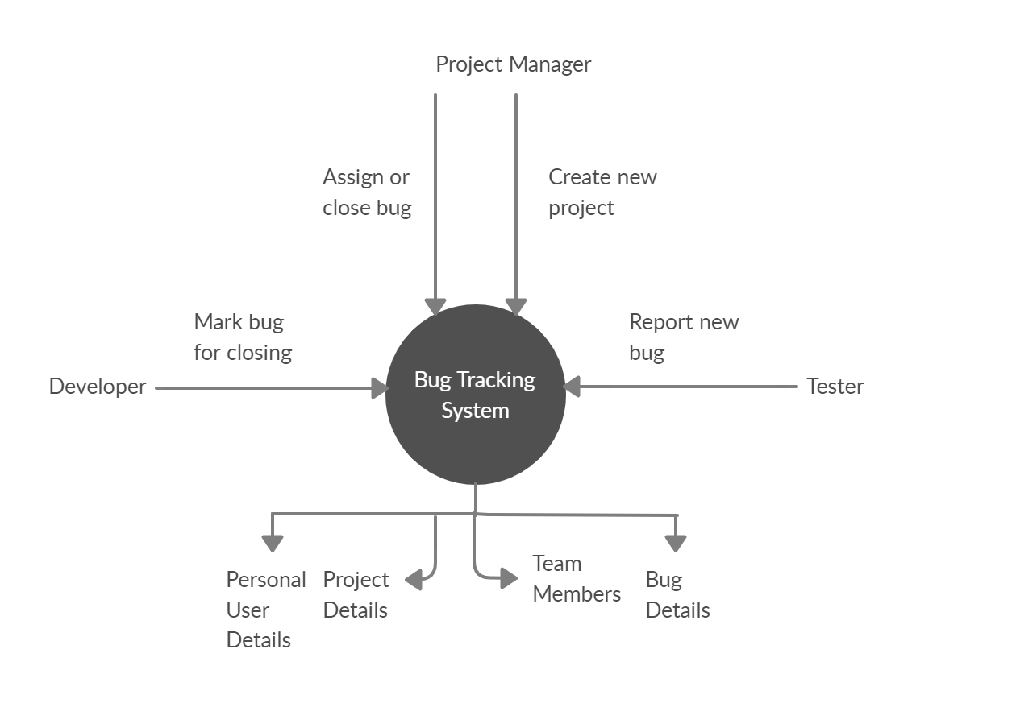DFD Level 0

DFD Level 1

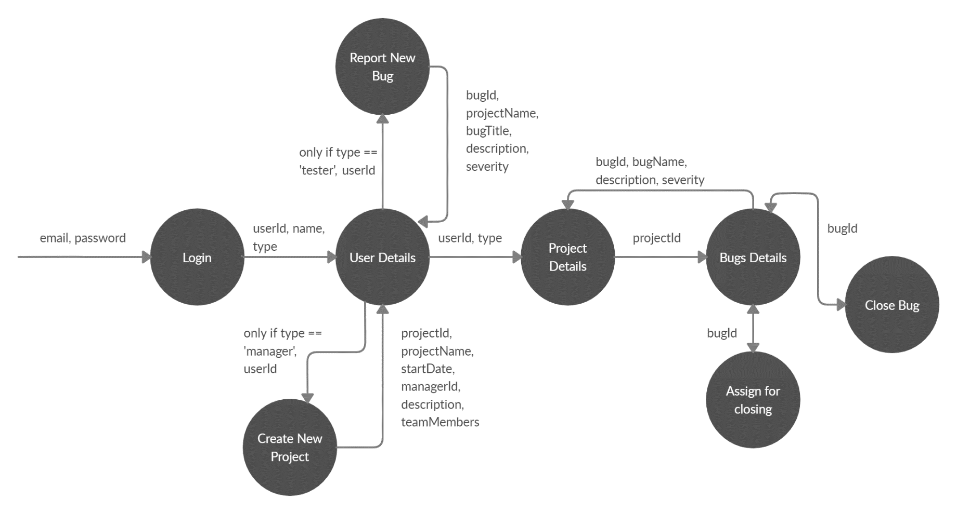

DFD Level 2

